SA Assignment 9

A software connector is an architectural element that models interaction among components and defines rules that govern these interactions. A software connector can undertake one or more of the four roles mentioned:

**1. Communication:**

* Connectors providing communication services support transmission of data among components.
* Data transfer services are primary building block of component interaction.
* Components routinely pass messages, exchange data to be processed and communicate results of computations.

**2. Co-ordination:**

* Connectors providing co-ordination services support transfer of control among components.
* Components interact by passing the thread of execution to each other.
* Function call and method invocation are examples of co-ordination connectors.
* Higher-order connectors, such as signals and load balancing connectors provide richer, more complex interaction built and coordination services.

**3. Conversion:**

* Connectors providing conversion services transform the interaction required by one component to that provided by another.
* They enable interaction of independently developed, mismatched components; there by enabling heterogeneous components to interact with each other.
* Mismatches are based on incompatible assumptions made by components about the type, number, frequency and order of interaction.
* Examples of converters are adaptors and wrapper connectors.

**4. Facilitation**

* Connectors providing facilitation services mediate and streamline component interaction.
* They enable interaction of components intended to interoperate and govern access to shared information.
* They can also provide synchronization mechanisms as in critical sections using monitors.
* They ensure proper performance profiles such as load balancing services and concurrency control which may be required to meet certain non-functional system requirements and to reduce inter-dependencies among interacting components.

**A. Event Connectors**

An event is defined as the instantaneous effect of the invocation of an operation on the object, which occurs at the objects location. The event connector provides co-ordination and communication service. The event connector type and its variation are shown below:

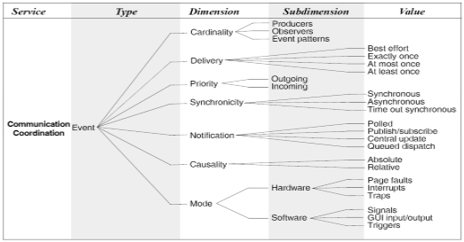

**B. Arbitrator Connector**

When components are aware of the presence of other components but cannot make assumptions about their need and state, arbitrators streamline system operation and resolve any conflicts and redirect the flow of control. The arbitrator connector type and its variation are shown below:

